- Dr CHUNG Kin Lai
Chief Executive Officer of CUHK Medical Centre
Year registered as The Medical Council of Hong Kong Listed Medical Practitioners

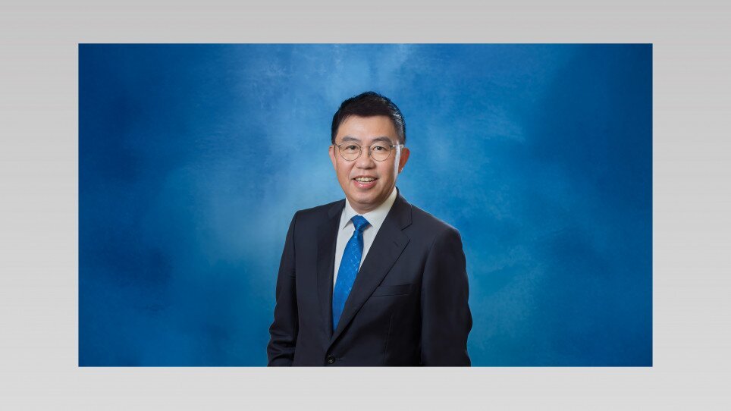 | Dr Chung is a specialist in Emergency Medicine by background, and is an experienced senior executive with extensive experience in hospital management. Prior to his current position – the CEO of CUHK Medical Centre, he was the Cluster Chief Executive of New Territories East and Hospital Chief Executive (HCE) of Prince of Wales Hospital under the Hospital Authority (HA) since December 2022, overseeing 7 hospitals and medical institutions providing public health services to residents of Shatin, Tai Po and North District. Dr Chung has also served as the HA Director (Quality & Safety), leading various support services for the Government in areas including infection control, disaster emergency response, etc., as well as administering public hospitals’ quality & standards, patient safety, clinical incident management, etc. Dr Chung possesses substantial experience in hospital operation and medical services management, and has shouldered many other important roles including Consultant (Emergency Medicine) of Tuen Mun Hospital, HCE of Castle Peak Hospital and Siu Lam Hospital, and HCE of North District.

- Dr CHOI Hiu Yeung, Jacqueline
Medical Director, Business Development of CUHK Medical Centre
MB ChB (CUHK); MRCP (UK); M Med (Public Health) (Singapore); Dip Med (CUHK); FHKCCM; FFPH; FHKAM (Community Medicine)
Year registered as The Medical Council of Hong Kong Listed Medical Practitioners

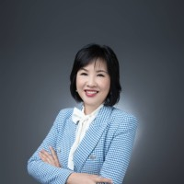 | Dr. Jacqueline Choi is an experienced specialist in public health medicine and currently serves as Medical Director of Business Development, as well as a Consultant Physician at the CUHK Medical Centre. Her contributions to public health and primary care are well recognized. She also holds honorary clinical professorships at the Jockey Club School of Public Health and Primary Care of the CUHK Faculty of Medicine, as well as at the Li Ka Shing Faculty of Medicine of the University of Hong Kong. She holds several professional qualifications, including a Bachelor of Medicine and Bachelor of Surgery from CUHK, a Fellowship of the Royal College of Physicians (UK), and a Master of Public Health from the National University of Singapore. She also holds a Diploma in Internal Medicine from CUHK and is a Fellow of the Hong Kong College of Community Medicine, the Royal College of Physicians (Public Health) (UK), and the Hong Kong Academy of Medicine (Community Medicine).  In a previous appointment as a government official in the Department of Health of the Hong Kong Special Administrative Region Government, Dr. Choi led initiatives in primary care development, community liaison, and chronic disease surveillance. She also provided direct patient care in the internal medicine stream of the Hong Kong Hospital Authority.
- Dr CHAN Ho Yan, Yolanda
MB BS (HK); FHKAM (Surgery); FCSHK; FRCSEd
Year registered as The Medical Council of Hong Kong Listed Medical Practitioners

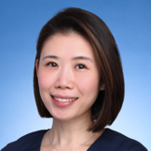 | Dr Yolanda Chan is currently a Consultant of General Surgery at CUHK Medical Centre. She obtained her specialist qualification in General Surgery in 2012, and has developed extensive experience in breast surgery through her early subspecialty training under the College of Surgeons of Hong Kong and her key role in the multidisciplinary breast service at Kwong Wah Hospital, with a particular focus on comprehensive breast care and women’s health.

- Dr LAW Ying Kan, George
MB ChB (CUHK); FRCSEd(Orth); FHKAM (Orthopaedic Surgery); FHKCOS
Year registered as The Medical Council of Hong Kong Listed Medical Practitioners

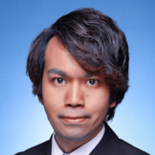 | Dr George Law is currently a Consultant of Orthopaedic Surgery at CUHK Medical Centre. He obtained his specialist qualification in orthopaedic surgeon in 2015, and has received advanced clinical training at leading institutions including United Christian Hospital, Prince of Wales Hospital and Alice Ho Ming Ling Nethersole Hospital with a focus on Sports Medicine and Arthroscopic Surgery.

- Dr YEUNG Suet Ying, Carol
MB ChB (CUHK); MRCOG; FHKCOG; Cert HKCOG (Gynae Onc);
FHKAM (Obstetrics and Gynaecology)
Year registered as The Medical Council of Hong Kong Listed Medical Practitioners

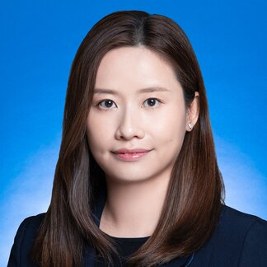 | Dr Carol Yeung is currently a Consultant of Gynaecology at CUHK Medical Centre. She received her training at Prince of Wales Hospital and obtained her specialist qualification in O&G in 2017. She has received advanced training in gynecological oncology, and accredited as a subspecialist by HKCOG in 2022.

- Dr NGO Chang Chung
MB BS (HK); FRCSEd (Urol); FCSHK; FHKAM (Surgery)
Year registered as The Medical Council of Hong Kong Listed Medical Practitioners

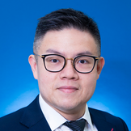 | Dr Ngo Chang Chung is currently a Consultant of Urology in CUHK Medical Centre. He obtained his fellowship in Urology in 2016 and underwent laparoscopic and robotic surgical training at the First Affliated Hospital, Zhejiang University School of Medicine, Hangzhou, China, and Vancouver General Hospital, University of Columbia, Canada in 2019.

- Dr LEUNG Kam Suet, Linda
MB BS (Lond); MRCP (UK); FHKCP; FHKAM (Medicine); MPH (HK)
Year registered as The Medical Council of Hong Kong Listed Medical Practitioners

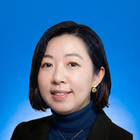 | Dr Linda Leung is currently a Consultant of Medical Oncology at CUHK Medical Centre. She obtained her specialist qualification in Medical Oncology in 2017, and has received advanced clinical training at leading institutions including Royal Marsden Hospital, United Kingdom and Prince of Wales Hospital, Hong Kong, with a special interest on lung cancer management.

